Student Guide and Task
This is the most complex generator in Semester 1: it composes four resource types into one image.
What you receive and what you must find yourself
- You receive (course resource pack): 1.a. portraits/ 200 synthetic face photos 1.b. signs/ signature and stamp PNGs with transparency 1.c. passport_generator.py (the code above) 1.d. coordinate_finder.py
- You must find yourself: 2.a. a cleared passport main-page template (spread layout) 2.b. all coordinates for your template
- You must NOT receive a ready template, finding and measuring it is the task.
Template rules
- The template must contain no real personal data (cleared only).
- No real security features.
- The code adds the watermark SYNTHETIC TRAINING SAMPLE - NOT A REAL DOCUMENT to every image. Do not remove it.
- Portraits are synthetic faces. Never substitute photos of real people without written consent.
Project folder structure
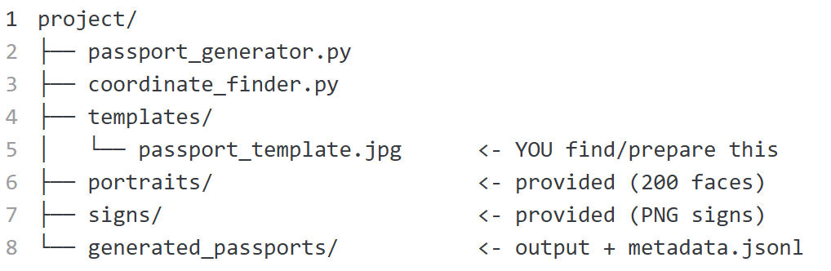
How the code works (block by block)
- CONFIG block — all positions. The only place you edit for your template.
- REGION_PACKS — consistent geography: department + oblast + region + cities + districts always match.
- generate_person_data() — Faker ru_RU names, dates, department code, passport number.
- fit_portrait() — center-crops your face photo to the photo window aspect, then resizes.
- add_rotated_text() — draws the passport number rotated 90° along the page edge.
- generate_dataset() — the factory loop: text → signs → photo → rotated number → watermark → save → metadata line.
How to run
Install dependencies:
pip install pillow faker matplotlib

First run (will fail on purpose until you do the task):
python passport_generator.py --n 5 --seed <your_student_ID>
Expected error before the task is done:
FileNotFoundError: Template not found: templates/passport_template.jpg
THIS IS YOUR TASK: find/prepare a cleared passport template first.
After you add the template and coordinates:
python passport_generator.py --n 5 --seed <your_student_ID>
Measure your template (the core of the task)
python coordinate_finder.py templates/passport_template.jpg
Click on every blank and write the numbers into this table:
Item | x | y
police_department
oblast
given_date
dep_number
surname
name
patronymic
gender
birth_date
city
district
region
photo window (top-left)
photo window (bottom-right) → width = x2−x1, height = y2−y1
rotated number position 1
rotated number position 2
sign position 1
sign position 2
Then copy the values into the CONFIG block of passport_generator.py.
Task requirements
- Find or prepare a cleared passport main-page template and save it as templates/passport_template.jpg.
- Measure all positions with coordinate_finder.py and fill the table.
- Put your coordinates into the CONFIG block.
- Run the generator with --n 5 --seed <your_student_ID>.
- Open all 5 images and check: 5.a. every text value sits inside its blank line; 5.b. The portrait is inside the photo window, face not stretched; 5.c. both signs are in the signature/stamp areas; 5.d. the rotated number runs along the page edge, not over text; 5.e. the red watermark is visible.
- Break one coordinate on purpose, regenerate, observe the defect, then fix it.
- Open metadata.jsonl and verify one record matches its image (surname, date, passport number).
Dataset card (report) should explain
- Which template was used and where it came from.
- How coordinates were measured.
- Which fields are generated and how (Faker, region packs).
- Which seed was used?
- What problems appeared (overlaps, photo crop, sign transparency).
- Ethics statement (synthetic portraits, watermark, no real data).
- What should be improved next (blur, glare, perspective, YOLO labels).
Homework options (if class time is not enough)
- 100 passports + metadata audit (script that checks every JSONL line has an existing image) + propose two defect augmentations (blur, glare) for the next stage.

